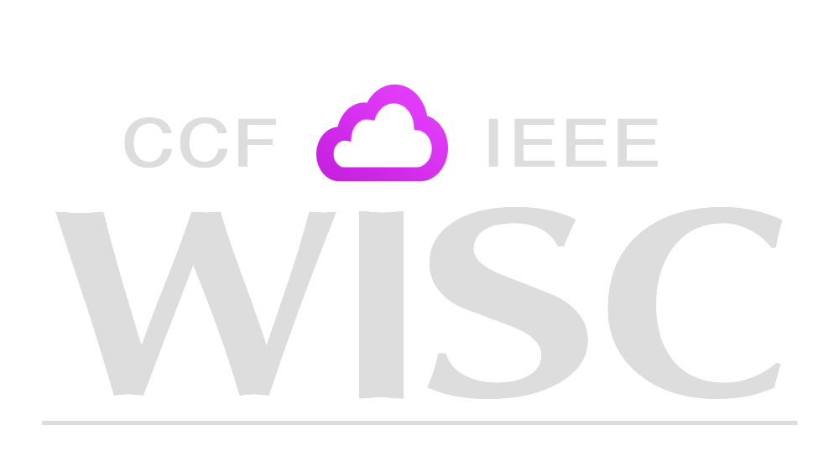
Women in Services Computing Symposium
2026 Scholarship Application Packet
Timeline
June 12 2026: Submission Deadline
June 26 2026: Acceptance Notification
July 13 2026: Awardee public announcement

Contact: Lorraine M Herger
wiscscholarship@gmail.com

Please note that you must be a current female student in fall 2026 to be considered for this scholarship.

Application Items
Contact and Academic Information [Section A]
Official Transcripts [Section A]
Recommendation Letter: [Section A]
Short Bio (maximum 200 words) [Section B]
Personal Statement (500 word maximum) [Section C]

Please submit to:
wiscscholarship@gmail.com

Consent and Release Form: submit as a separate document with your application. Applications without this form will not be considered.

I am applying for the WISC Scholarship: (yes/no) ___

FILE NAME FORMAT

Application:
Lastname_firstname_scholarship.pdf
Transcripts:
Lastname_firstname_{degree name}_trans.pdf

Letters of recommendation:
Lastname_firstname_recommendation.pdf

Consent and Release form:
Lastname_firstname_CandR.pdf

Section A
Email Address:

Address (ZIP) Code

Country:

State:

State
City:

Home Address line 2

Home Address line 1:

Phone Number (include country code)

Name of Applicant (First, Middle, Last)
Academic Institution and Academic Status Information
Undergraduate:
Current College/University Name:
Years attended
Status (Freshman, Sophomore, Junior, Senior)
Expected Graduation Date
Major:
GPA:

Master:
Current College/University Name:
Years attended
Status
Expected Graduation Date
Major:
GPA:

PhD:
Current University Name:
Years attended
Status
Expected Graduation Date
Major:
GPA:

Transcripts: Please check the box for the transcripts you are submitting:
Undergraduate Transcript ☐
Master Transcript ☐
PhD Transcript ☐

Recommendation Letter:
- Ensure your name and email address are included in the recommendation letter, as well as the recommender’s relationship to the applicant
- Limit 1 page
Name of Recommender
Title
Relationship to Applicant

Section B
Short Bio
Short Bio

Section C
Personal Statement (not to exceed 500 words)
The personal statement should reflect technical interests, career goals, community involvement, etc.
Personal Statement

